**ABSTRACT-**

Natural language processing (NLP) is the study of computer and mathematical modelling of many elements of language, as well as the development of a wide range of systems. One example of this is spoken language systems, which combine speech and natural language; another is cooperative interfaces to databases and knowledge bases that simulate various aspects of human-human interaction; a third is multilingual interfaces; a fourth is machine translation; and a fifth is message-understanding systems. Logic, psychology, computer science, linguistics, and multidisciplinary research are all heavily used within NLP research. NLP has a unique position in computer science since many elements of the discipline deal with the linguistic aspects of computing, and NLP aims to computationally model language.

OBJECTIVE-

The goal of this project is to use natural language processing to determine if the provided news is true or false using a list of keywords and events.

**INTRODUCTION-**

**Artificial intelligence (AI) has a subfield called Natural Language Processing (NLP) that studies how computers and human languages interact. Text and voice in natural language may be analysed, comprehended, and produced using NLP. NLP seeks to replicate how people process language by giving computers the ability to comprehend and interpret human language.**

**Applications for NLP approaches are numerous, including:**

1. **Voice recognition and transcription: NLP methods are used to turn spoken words into written ones, which is important for activities like dictation and voice-activated assistants.**
2. **Text translation: NLP methods are used to translate text from one language to another, which is helpful for e-commerce and other jobs that need international communication.**
3. **Text summarising: NLP methods are used to condense lengthy texts into manageable chunks, which is beneficial for tasks like document indexing and news summaries.**
4. **Sentiment analysis: NLP techniques are used to identify the sentiment or emotion represented in text, which is essential for projects like analysing customer comments and keeping an eye on social media.**
5. **Answering inquiries in natural language is possible with the use of NLP methods, which is helpful for chatbots and virtual assistants, among other applications.**
6. **NLP is a fast expanding discipline that is employed in a variety of sectors, including customer service, e-commerce, healthcare, and education. Moreover, NLP is used to enhance the functionality of natural language processing-based systems, such as chatbots, virtual assistants, recommendation engines, and more. The development of NLP has made it feasible for machines to comprehend and interpret human languages in a way that may be utilised for a variety of tasks, including speech recognition, language translation, question-answering, and more.**

**CODE-**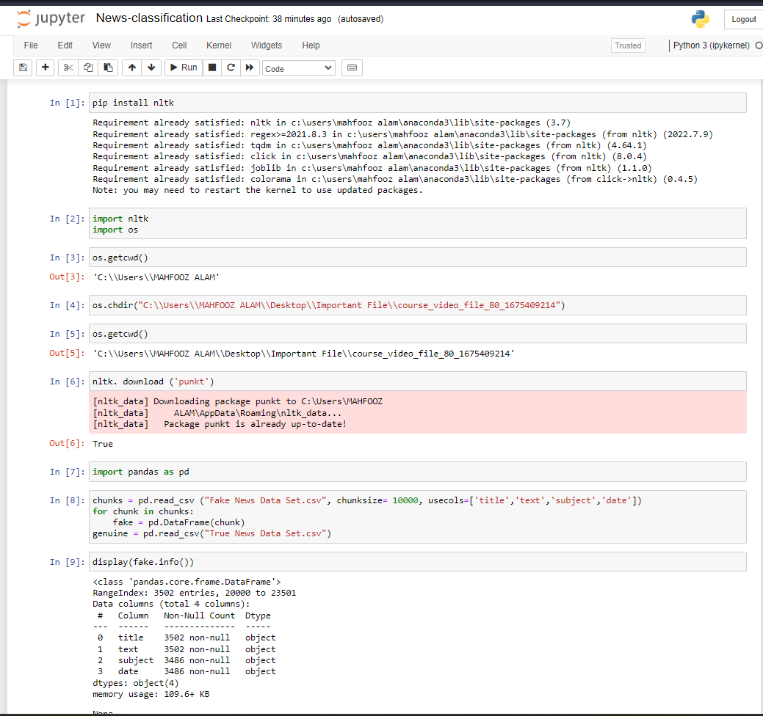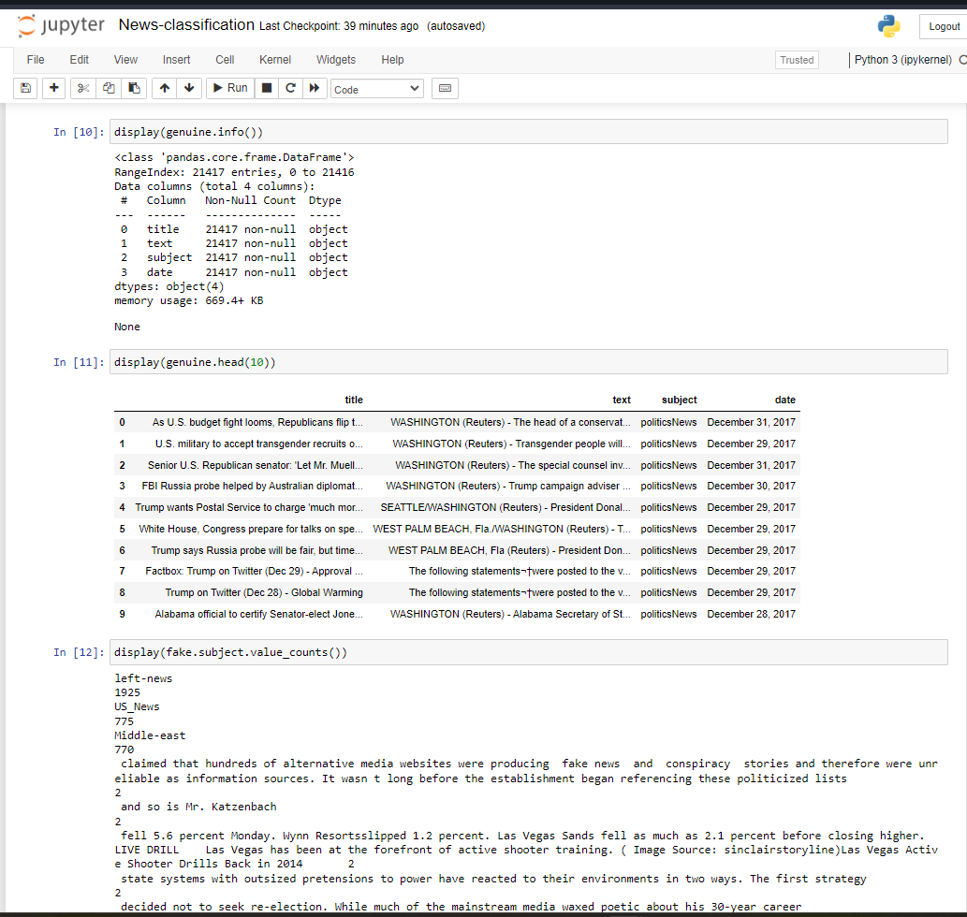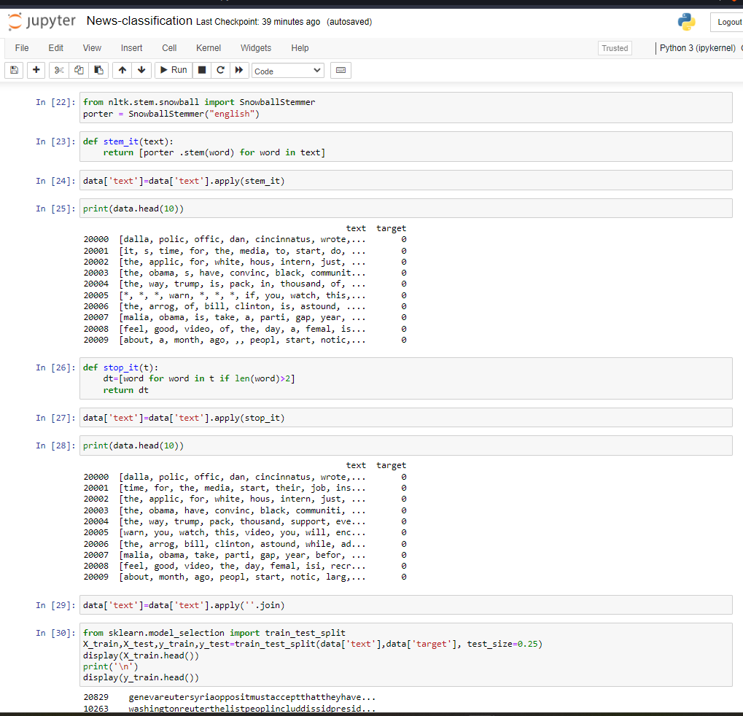

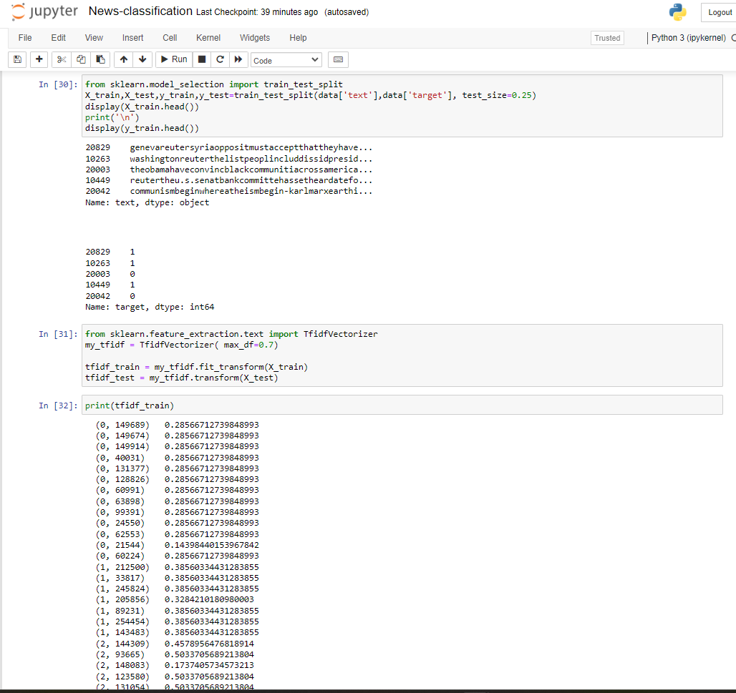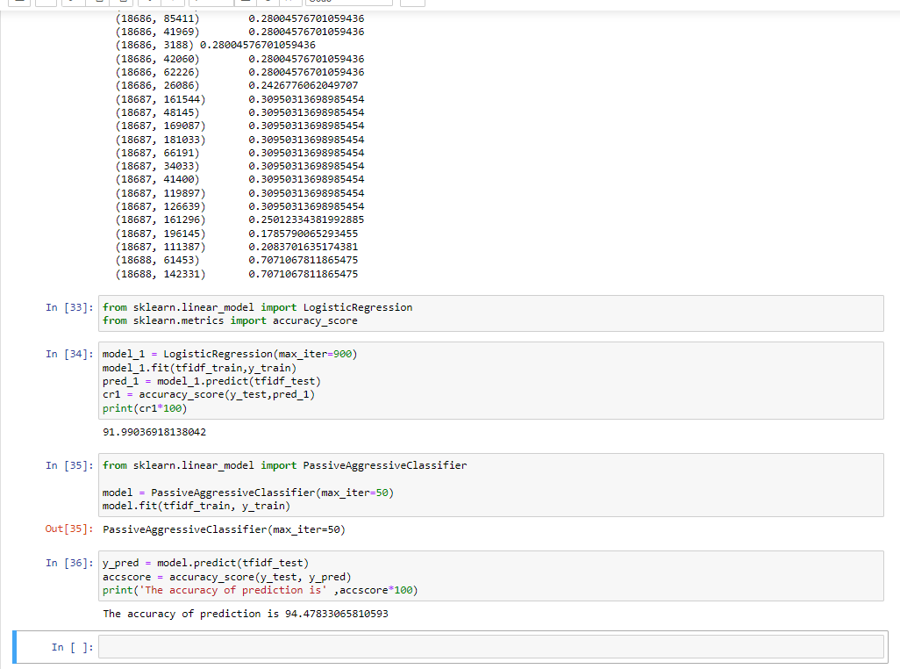

SOURCE CODE FOR NEWS CLASSIFIER PROJECT- 

CONCLUSION-

Following are the methods through which we are able to make this project working:-

1) Supervised Learning

2) Text- Preprocessing

3) Vectorization

4) Scikit Learn NLP imports

5) Natural language toolkit

6) ML Classifiers(Passive-Aggressive or Logistic regression).

And it's providing accuracy above 90% and it taught me a lots of new things that I haven't ever known.